CYB102 Project 3 (🔗 Instructions Page)

👤 Student Name: Shireen M
✉️ Student Email:

Reflection (Required)

🤔 Reflection Question #1: If I had to explain “what is a directory traversal attack” in 3 emojis, they would be…
(Feel free to put other comments about your experience in this unit here, too!)
📁➡️🔓
Honestly this project took me a while to get working. I kept hitting random errors port already in use, wrong URL format, miscounting how many ../ I actually needed to climb out of the folder. But once it finally worked and I saw the passwords.txt files from other folders pop up, it just clicked. Way better than reading a definition of "directory traversal" in a textbook.

🧠Reflection Question #2: Why do we use a .sh file to run our attack?
A .sh script lets us automate and chain together every step of the attack into one repeatable command starting the vulnerable server in the background, waiting for it to initialize, sending the malicious traversal request, and cleaning up the server process afterward. This mirrors how real attackers or security researchers script exploits rather than manually typing each step, and it makes the attack reproducible for testing, demonstration, or grading purposes

📣 Shoutouts: Share appreciation for anyone who helped you out with this project or made your day a little better!
Shoutout to Claude for helping me actually understand what was going wrong every time my script broke between the bash syntax issues and figuring out the right path depth, I would've been stuck a lot longer without it.

Required Challenges (Required)

Item #1: A screenshot of your completed attack.sh file:
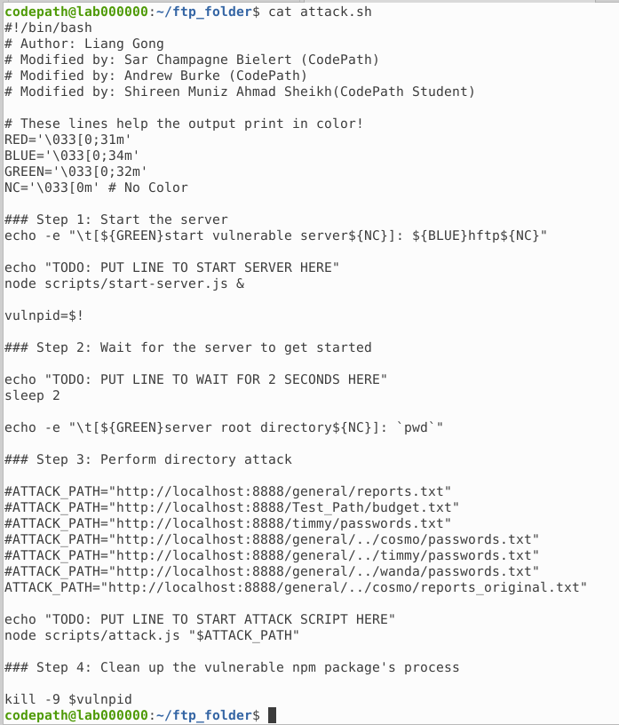

Item #2: Three different file paths the Directory Traversal attack was able to access:
- http://localhost:8888/general/../cosmo/passwords.txt
- http://localhost:8888/general/../timmy/passwords.txt
- http://localhost:8888/general/../wanda/passwords.txt

Stretch Challenge (Optional)

Item #1: A screenshot of your Directory Traversal attack output to find the REAL earnings:
(using the cat command to view the file doesn’t count!)
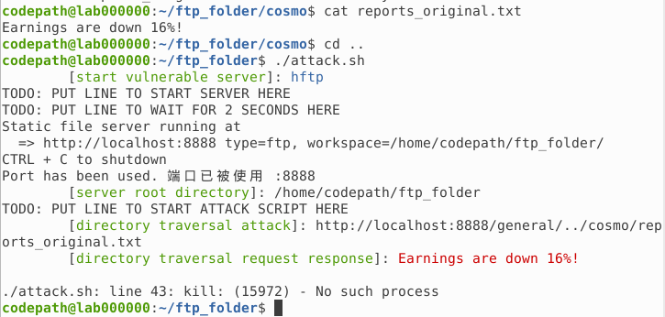

Submission Checklist
👉Check off each of the features you have completed. You will only be graded on the features you check off.

Required Challenges
- Item #1
- Item #2

Stretch Challenge
- Item #1

💡Tip: You can see specific grading information, including points breakdown, by going to 🔗 the grading page on the course portal.

